Breast Cancer Classification

1. Architectural Components Overview

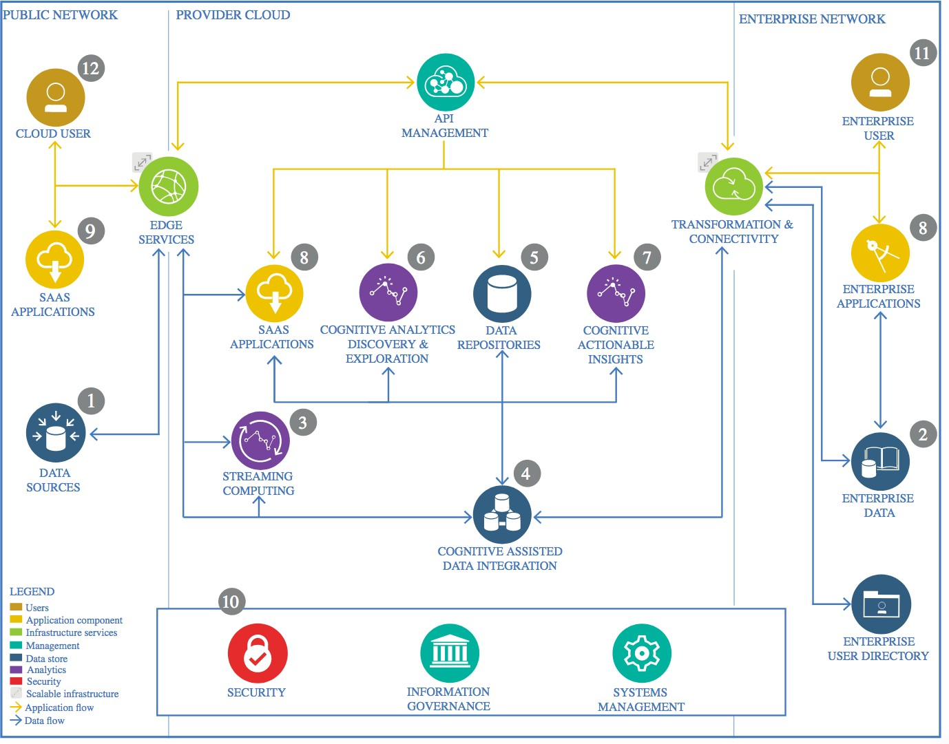

IBM Data and Analytics Reference Architecture. Source: IBM Corporation

## Data Source

* + 1. Technology Choice

The dataset selected for this project represents Breast Cancer from the Wisconsin Breast Cancer Database.

It contains data of 357 benign and 212 malignant cancers.

Link to database:

https://archive.ics.uci.edu/dataset/17/breast+cancer+wisconsin+diagnostic

* + 1. Justification

CSV file with the results of science research. It is a typical format for the stable research data.

## Enterprise Data

* + 1. Technology Choice

This component is not needed in this project.

* + 1. Justification

We are using a CSV file as a data source since our data does not require frequent updates, therefore, a cloud-based solution for enterprise data is not needed.

## Data Integration

* + 1. Technology Choice
* For data preprocessing, we handled the dataset as a Pandas data frame object, a 2- dimensional labeled data structure with the index for rows and columns.
* We used LabelEncoder for the target feature to one-hot-encode categorical features and RobustScaler, StandardScaler and MinMaxScaler to scale numeric features.
* Additionally, PCA Analysis and Feature Importance is performed to check dimensionality reduction
  + 1. Justification

Panda's data frame structure is fast and has high productivity and performance, and it is suitable for our two-dimensional dataset. We used these preprocessing to perform the feature transformation and feature creation steps.

## Data Repository

* + 1. Technology Choice

The CSV file with the dataset is saved in the GitHub repository to be used in the analysis. It can be also downloaded on the above link website.

* + 1. Justification

Based on the nature of the data and the objective of the analysis, the dataset will not require frequent updates for future models’ training, therefore, the GitHub repository is a sufficient and efficient technology for our case.

## Discovery and Exploration

* + 1. Technology Choice

In order to visualize the data in a structured manner, the Pandas framework has been used. During the exploration of data, I have used Pandas, Seaborn, Plotly and Matplotlib Python packages to visualize the distribution of various features to understand their effectiveness for further processing.

* + 1. Justification

These visualizations provide a brief idea about all the features along with the frequency of the corresponding values. During this phase, the following analysis has been performed.

* Feature Distribution
* Outliers
* Correlations

## Actionable Insights

* + 1. Technology Choice

We have used Scikit-Learn and Pyspark framework to develop different machine learning models. We have imported the following model classes along with the different accuracy measures.

* RandomForestClassifier
* accuracy_score
* classification_report
* confusion_matrix
  + 1. Justification
* The machine learning classifier help to predict the diagnosis based on the selected features.
* The accuracy measures will be needed to perform the performance comparisons of these models.
* The classification report and confusion matrix will help to understand the model performance.

## Applications / Data Products

* + 1. Technology Choice

The data produced for this project is an ipynb file of the analysis generated from the “IBM_Capstone_Project.ipynb” Jupyter Notebook,

* + 1. Justification

The main motivation behind this work is to build an intelligent system to predict breast cancer on the given data. Some major objectives include:

* Exploratory Data Analysis to get an insight of each feature.
* Correlation Analysis to check collinearity.
* Classification Analysis to predict the breast cancer.

## Security, Information Governance and Systems Management

* + 1. Technology Choice

This component is not needed.

* + 1. Justification

The dataset used for this project is public, therefore no information governance and system management are needed.